9
Agricultural Crop-Yield Prediction: Comparative Analysis Using Machine Learning Models

Kukatlapalli Pradeep Kumar, S. Babu Kumar, Amarthya Dutta Gupta, Kevin Johnson,
and Meghan Mary Michael
CHRIST (Deemed to be University), Kengeri Campus, Bangalore, India

INTRODUCTION
The economy of emerging countries like India greatly benefits from agri- culture, which is one of the most popular habitations. About 200.2 million hectares of land are used for agriculture in India, which is a significant source of income [1]. In India, 70% of the population relies on it for a liv- ing. Our economy is under pressure to increase food output because of overpopulation. In recent years, there has been a broad desire for growth across many industries due to the quick development of information tech- nology [2]. One of the sectors with a lot of space for development is agricul- ture. This disadvantage is mostly due to the lack of a reliable agricultural model and enough farmer guidance. Implementing smart agricultural applications in isolated Indian villages is extremely difficult, especially when it comes to meeting community demands. For instance, illiterate and impoverished people cultivate rice using traditional ways.
Farmers will find it easier to make decisions if there is a mechanism that can automate irrigation, determine the quality of the soil, and forecast weather conditions, as well as price. Agriculture must be greatly advanced through innovations in this age of digitalization if it is to reach out to mar- ginalized and small-scale farmers. Several harvests were lost each year as

158 DOI: 10.1201/9781003485179-9

a result of inadequate technical expertise and unanticipated patterns in the weather, such as temperature swings and rainfall, which had a consid- erable effect on agricultural yields and revenue.
Crop yield prediction is a crucial responsibility for agricultural factors. The management of maintaining the agricultural factors and ensuring the highest output depends heavily on crop yield prediction (CYP). The two most crucial feature sets are what CYP mostly focuses on. According to the farmer, one set of data includes the methods used for irrigation, fertil- izer application, and field preparation. Environmental variables that are governed by nature, such as solar radiation, temperature, and rainfall, are included in a further set of data. Communication with field management methods and environmental factors affect how genetic markers behave. The sheer number of variables that must be taken into consideration makes it nearly difficult to predict crop yields with any degree of precision. Precision agriculture, which incorporates agricultural yield prediction, has several advantages, including enhancing crop output and quality while lowering environmental impact. Understanding the combined impacts of deficits in nutrients and water, illnesses, pests, and other vari- ables in the field over the growing season is made easier by using crop yield simulations. This may result in environmentally conscious agricul- ture methods that also benefit society at large [3].
Crop yields may be harder to forecast due to interactions between geno- types and environmental variables. It is hard to accurately predict the complex nonlinear effect of outside influences, including the weather. Understanding the cumulative impacts of water and nutrient deficits, pests, illnesses, the influence of crop yield variability, and other variables in the field across the cultivation season is made easier with the assistance of crop yield simulations. Additionally, while making financial decisions, farmers and cultivators take crop projections into account. The two big- gest obstacles in the current era of digital agriculture are collecting data and data integration.
Machine learning (ML), which is a subset of AI, concentrates on learn- ing, and it is a spontaneous process that provides the best CYP, depending on a number of factors [4]. The ML approach analyzes a dataset to find information, patterns, and connections. The dataset should be used to train the algorithm so that the results may be predicted based on prior knowledge. The prediction technique is constructed using several charac- teristics; for instance, model parameters can be corroborated using data from the learning. Based on the presented features, ML is a practical

technique that improves agricultural output forecasts. Numerous studies have used ML techniques for categorizing CYP, including random forests, regression trees, and multivariate regression. By analyzing past data, we may choose the prediction model’s parameters during the later phase of training. The evaluation takes a fraction of the preceding data into account. Numerous techniques, including classification and clustering, are used for the prediction. Information is taken out of the data [5].
Agro-businesses can manage supply chain choices like production scheduling by using exact risk and crop production forecasts. Crop output forecasts serve as the cornerstone for marketing. Crop identification and mapping gain from the use of multitemporal imaging, which makes it possible to classify costs by accounting for variations in crop type reflec- tance. Using agricultural yield indicators to identify problems early and apply solutions might increase crop output and profitability. One new development is the use of hybrid models, which mix several ML methods to increase accuracy.
Artificial neural networks (ANNs) with the study of representations are used in deep learning, a branch of ML. In the presence of complex data, such as maturity groups and zones, genetic details, and various meteo- rological conditions, deep-learning methods may provide answers. The nonlinear relationships between projected yield alongside the multivari- ate data inputted (cluster information, meteorological factors, and matu- rity group) may be learned extremely effectively using this technique. The long-term temporary dependency in challenging multiple-variate sequences can be captured by the Long-Short Term Memory (LSTM) net- work, which is very beneficial for time series modeling. The prediction potential of ML models may also be increased by combining data from other sources, such as 3D mapping, sensor-based social condition data, and drone-based soil color data.

LITERATURE REVIEW
Crop yield is a topic that is of much economic and global importance. It can help manage agricultural resources efficiently and ensure food secu- rity. Advancements in CYP can boost the economy of a country and help in the decision-making process for farmers with respect to planting, harvest- ing, and resource allocation. These literary articles serve as the foundation

for this chapter, which aims to come up with a model that can take the outcomes and observations from these studies further. This section of the chapter presents the preexisting studies conducted on CYP using various models such as deep learning, neural networks (NN), and ML models.

Neural Networks
Inam Ali et al. [6] find correlations between attributes from existing rice data and implement ML and analytics-based approaches to CYP. The study focuses on the data obtained from the district of Larkana in Pakistan, which hadn’t previously been researched from the agricultural yield aspect. The agricultural sector in Pakistan contributes significantly to the economy of the country. The study found that by using the Apriori algorithm on the rice crop dataset of Larkana, researchers were able to share vital yield predictions, which could be broadly extended to other crops by altering the specific attributes. The data utilized for the study was collected from various local associated departments. The final rice yield dataset contained the targeted parameters: year, yield, humidity, wind speed, rainfall temperature, and area. The data collected contained the data for the aforementioned parameters for a duration of six years. The NN approach was used for the optimization of rice yield data, as it is very important and is preferred due to its level of accuracy being acceptable. NNs were used to optimize the results of rice yield prediction, which pro- vides high-value yield that would be beneficiary to farmers, local agricul- turalists, and government officials to make decisions based on rice crops. They can evaluate forecasting values of the connected variables outlined in the research and utilize this data, together with historical patterns, to make better data-driven decisions. The results of the study can strengthen the economy of the country by increasing rice production and also aid in preventing monetary losses incurred by farmers.
In the study by Gopi et al. [7], NNs, specifically an ensemble recurrent neural network (ERNN), are used with the Red Fox Optimization (RFO) technique for crop advice and yield forecasting. Precision farming benefits from increased crop quality and yield with no negative environmental effects. It focuses on monitoring reactions to inter- and intravariability in agricultural systems, management information systems, variable rate technologies, and others. Farmers use conventional farming patterns to make decisions related to crop production and cultivation, but in order to aid in generating data-driven judgments after accounting for variable

aspects, an automated crop recommendation system is needed. A crop advice and yield forecasting dataset from the Kaggle repository was used to validate the RFOERNN-CRYP technique experimentally. The technique will help farmers by assisting them in the decision-making process by accounting for the various relevant agricultural parameters. The RFO method is used in the hyperparameter selection procedure, which improves the performance of the ensemble learning process. This also ensures that the accuracy of the model is maintained from the root up. Through the performance of many experimental analyses, it was found that the results of the RFOERNN-CRYP were optimistic, with a maximum R2 score of 0.9988 and an accuracy of 98.45%. The model proposed in the study can be trialed on real-life, larger datasets in the future. Additionally, the scope of employing deep learning and computer vision technologies-based crop phenotyping detection models will be made possible.
Muthukumaran et al. [8] sought to improve the yield of paddy by utiliz- ing evolutionary computation techniques to predict the nature of the factors influencing growth rate with the intent of improving food security. The researchers focused on analyzing the real-time, day-to-day impact of mete- orological phenomena, wind speed, wind direction, and relative humidity instead of relying on historical records. A ROANN Algorithm was used for prediction, and the Multi-Objective Particle Swarm Optimization Algorithm and Genetic Algorithm were utilized to optimize input param- eters and reconstruct the database. It is observed that the proposed ROANN algorithm predicts the factors farmers need to focus on while correlating the various meteorological phenomena. The optimization techniques were successful in identifying input parameters from the real-time dataset. Maximum accuracy and minimum error rates were observed upon tuning the NN parameters with hidden layers and learning rates.
A paper by Vignesh et al. [9] aims to predict crop yield using a Visual Geometry Group (VGG) and Discrete Deep Belief Network with the net classification method to create CYP systems to connect raw data to predic- tions of crop yield. To accomplish this, the researchers gathered data param- eters from India’s state agriculture website, which served as the foundation for their predictive model. The data parameters collected from the agricul- ture website were fed into the network, which comprises multiple stacked layers. These layers process the input parameters sequentially, ultimately forming a comprehensive framework for crop production prediction. To optimize the input data for the most effective results, the researchers employed a technique called “tweak chick swarm optimization.”

This optimization method refines and preprocesses the input data, ensuring that the most relevant and valuable characteristics are extracted. The resulting refined data is then fed into the classification process as input. To perform the actual classification and predict agricultural yields, the researchers utilized both the Discrete Deep Belief Network and the VGG Net Classifier. The outcome of their approach is notably impressive, sur- passing previous methods in terms of predictive accuracy. Specifically, this model achieves an impressive accuracy rate of 97%, underscoring its proficiency in selecting the crop varieties that are likely to yield the high- est profits.

Optimization Algorithms
The study by Mohsen Yoosefzadeh et al. [10] aims to improve the genetic yield potential in the soybean crop, which is a major food-grade crop that could potentially be the most sustainable solution to tackling the rising food security concerns and global demand. Five traits were identified first as the most significant soybean yield component attributes were assessed. ML algorithms were used both separately and collectively on the selected data through an ensemble method using the Random Forest (RF) algo- rithm, Multilayer Perceptron (MLP), and Radial Basis Function (RBF). Out of these techniques, the RBF algorithm was the most efficient with the coefficient of determination (R2) of 0.81 and the lower mean absolute errors (MAE) of 148.61 kg.ha−1and root mean square error (RMSE) values of 185.31 kg.ha−1. The RBF was selected as the subclassifier for the E-B algorithm. Breeding approaches can be modified to improve the genetic prospective of complex traits, such as yield hinged on the secondary attri- butes that govern the final efficiency and result. Although the results of the study are promising, the measurement of the yield components is labor intensive and, therefore, cannot be applied to large-scale deployments and hence limits the use of this strategy to initiatives for cultivar development. The study will help breeders choose parental lines and carry out fruitful crosses, two crucial processes for breeders looking to develop cultivars with higher genetic production potential.
Predicting yield considering various irrigation kinds is ideal for opti- mizing resources. CYP plays an integral role in achieving irrigation sched- ules and assessing labor requirements for storing and reaping. The accuracy of CYP requires a detailed logical understanding of the relativity between yields and collaborative factors. To achieve this connection, large

datasets and an efficient model are required. Deep learning has been uti- lized in this research [11] to assess and analyze complex data like geno- types, weather parameters, maturity groups, etc. An Automated Crop Yield Prediction (ACYP) utilizing the Chaotic Political Optimizer with Deep Learning (CPODL) model is proposed. The steps involved in ACYP- CPODL technique are preprocessing and parameter optimization. For this model, the hyperparameter tuning is by the CPO algorithm. This technique has been able to achieve and produce reasonably successful results with a mean squared error (MSE) of 0.031 and an R2 score of 0.936. It should, however, be noted that the Bidirectional Long Short-Term Memory (BLSTM) model has also been able to produce results mirroring the aforementioned model to a good extent. A wider range of simulations on benchmark datasets has shown that in a comparative study, the better- ment in the predictions made by the ACYP-CPODL model is validated and verified to be true. It has demonstrated success as a technique for esti- mating agricultural yields. The design of fusion-based prediction models will improve the predictive outcome in the future.
The paper referenced as [12] seeks to harness the extensive data collected by Earth observation (EO) facilities to develop a model that can enhance predictions of crop yields. To achieve this, the study leverages EO data sourced from Sentinal-2 and Landsat-8 satellites to fine-tune the parame- ters of the APSIM-Maize model. To address the inherent uncertainties associated with soil properties, meteorological variables, and unknown management practices, a Monte-Carlo sampling method was employed. This approach enabled the researchers to account for and propagate these uncertainties effectively. Specifically, using both the mean values and uncertainty measures derived from the soil grids dataset, the study gener- ated 25 alternative representations or ensembles of the soil profile for each site, thus capturing the variability in soil attributes. The research made use of data collected from two key EO satellites, Sentinel-2 and Landsat-8, for calibration purposes. Sentinel-2 provided valuable observations of Leaf Area Index (LAI), while Landsat-8 contributed data related to the Normalized Difference Vegetation Index (NDVI). These specific variables were chosen because previous research has demonstrated their robust pre- dictive power in relation to crop yield. This analysis was instrumental in identifying the parameters within the APSIM model that exert the most significant influence on the prediction of maize LAI. By systematically assessing the sensitivity of these parameters, the research sought to enhance the accuracy and reliability of CYPs within the APSIM-Maize model.

According to the author [13], the production of agriculture involves a considerable deal of uncertainty; thus, it is impossible for any one approach to fully predict the end outcome. This limitation can be overcome by inte- grating swarm intelligence optimization with the fertilizer effect function to present many possibilities of validation findings under various random settings. This approach is more practical than conventional approaches like regression. It is emphasized that the limitations necessary for this [13] methodology will expand when the algorithm is applied in a real-world setting, perhaps causing results to deviate but not enough to affect the method’s application. In order to meet the objectives of scientific manage- ment, further work on the approach will concentrate on investigating a collection of predefined fertilization models. It was noted that the algo- rithm performs well in equation coefficient solving fitting and maximum yield solution. The findings demonstrated an increased fitting degree in the fertilizer impact equation capable of reasonably forecasting the accu- rate fertilizer application ratio and improving the yield.
The importance of crop production prediction in the agricultural industry is acknowledged in this paper [14]. It intends to make use of well-known ML methods, including long short-term memory and con- volutional neural networks. In order to estimate the yield for certain crops, it combines both of those models. The dataset used in this study included information on rainfall from 1901 to 2020, as well as agricul- tural yield information for cotton, maize, ragi, paddy, and sugarcane. These datasets were gathered from the website of the Indian government. To use all of this data efficiently in this study, it was integrated and pre- processed [15].
The improved optimization function (IOF) reduces the error and con- verges fast depending upon the back propagation used. After running the models, the following performance metrics were used for evaluation:
- Mean absolute percentage error (MAPE) – 0.836 to 1.245
- MAE – 0.054 to 2.321
- RMSE – 0.071 to 2.321
- Adjusted R-squared – 0.964 to 0.977

Remote Sensing and Imaging
This paper [16] deals with the usage of Unmanned Aerial Systems (UAS) Multispectral Imagery to predict the yield and to optimize the input

resource for the corn crop. An unmanned UAS can be used to get images that contain spatial and temporal information, which will be used to develop a statistical model to predict yield based on different phonologi- cal stages. Study [16] was conducted at the W. B. Andrews Agriculture Systems Research Farm at Mississippi State, Mississippi, United States. The data used was from the Delta Agricultural Weather Center. The field was subdivided into subplots, each with different treatments to identify which is the most ideal for the corn crop.
This paper realizes the significance of CYP in the agricultural sector. It aims to utilize popular ML techniques such as convolutional neural networks and long short-term memory. It combines both of those models to estimate the yield for certain crops. The data collected for this research were a dataset that contained the rainfall data from 1901 to 2020 and the crop yield data of paddy, maize, ragi, sugarcane, and cotton. These datasets were collected from the Indian government website. All of this data was combined and preprocessed to be used effectively in this study. The paper proposes an enhanced optimized function, i.e., an IOF, to reduce the error in CYP. The IOF function reduces the error and converges fast depending upon the back propa- gation used. After running the models, the following performance metrics were used for evaluation:
      - MAPE – 0.836 to 1.245
      - MAE – 0.054 to 2.321
      - RMSE – 0.071 to 2.321
      - Adjusted R-squared – 0.964 to 0.977

Feature Selection
This paper [17] deals with the aspect of feature selection for optimizing CYPs. Since there are multiple factors which are involved in predicting crop yields, selecting the required ones is important, as multiple factors affect the crop yield differently [17]. Sequential Backward Elimination Feature Selection Algorithm: AH, CL, TK, OW, and Tmax features

Correlation-Based Feature Selection Algorithm: AH, CL, TK, AT, Tmax, SD, NF, PF, and KF
Variance Inflation Factor: AH, CL, TK, TW, OW, RainF, AT, Tmin, Tmax, and SR features

Variance Inflation Factor: AH, CL, TK, TW, OW, RainF, AT, Tmin, Tmax, and R features
RF Variable Importance: AH, TK, OW, NF, PF, KF, and SD

Taking prediction dependent (PD) as the dependent feature and AH, OW, Tmax, TK, and CL as the independent features, we performed mul- tiple linear regression. They have also used an ANN, taking the dependent features as the input layer and PD as the output layer neuron. The final model’s accuracy was adjusted using correlation coefficient squared (R2) and came out to be 85% when only the selected features were used, whereas when all the features were used, the final accuracy came out to be 84%. This, therefore, could be used to conclude that the forward feature selec- tion algorithm is good for better prediction.

Precision Irrigation
This paper [18] deals with obtaining maximum yield from crops using subsurface water retention technology (SWRT). Here we tackle the pro- cess of determining the crop yield using algorithms. We require mainly two different factors to determine the yield. This study [18] was under- taken due to the high priority that sustainable crop cultivation has in our society. We need optimal coordination of food, water, and energy to keep on moving forward. Since water plays a huge role in agricultural development, the most efficient use of water plays a key role in the opti- mization of crop yield. SWRT is a method developed to improve the soil- water holding capacity in the plant root zone. Using the HYDRUS-2D software, we find the proper membrane design and installation depth in specific soil and weather conditions in sandy soils. Through various tests, it was concluded that the HYDRUS-2D model is highly reliable and has considerable accuracy. Although HYDRUS-2D can predict the water and nutrient accumulation at the root zone of a plant, it cannot simulate crop growth. To compensate for this shortcoming, we deploy the DSSAT software to give insights into crop yield from the specific soil-water mix. Using the proper mathematical modeling and proper use of both software, we can perform crop yield simulation under different SWRT membranes. The tests and results in this paper [18] help us con- clude that using both DSSAT and HYDRUS-2D, will help cut down on the human effort of optimizing certain parameters, which will result in increased crop production.

METHODOLOGIES

Preprocessing
Preprocessing plays a vital role in designing an ML algorithm, as most algorithms require data to learn from and provide predictions. If the data is not up to the mark, the predictions will be really inaccurate.
The preprocessing we have done in the selected dataset includes the following:
- Outlier Analysis
- Correlation Analysis
- Updating Missing Values
- One-Hot Encoding
Figure 9.1 is the heat map showing the correlation between all variables in our final dataset:
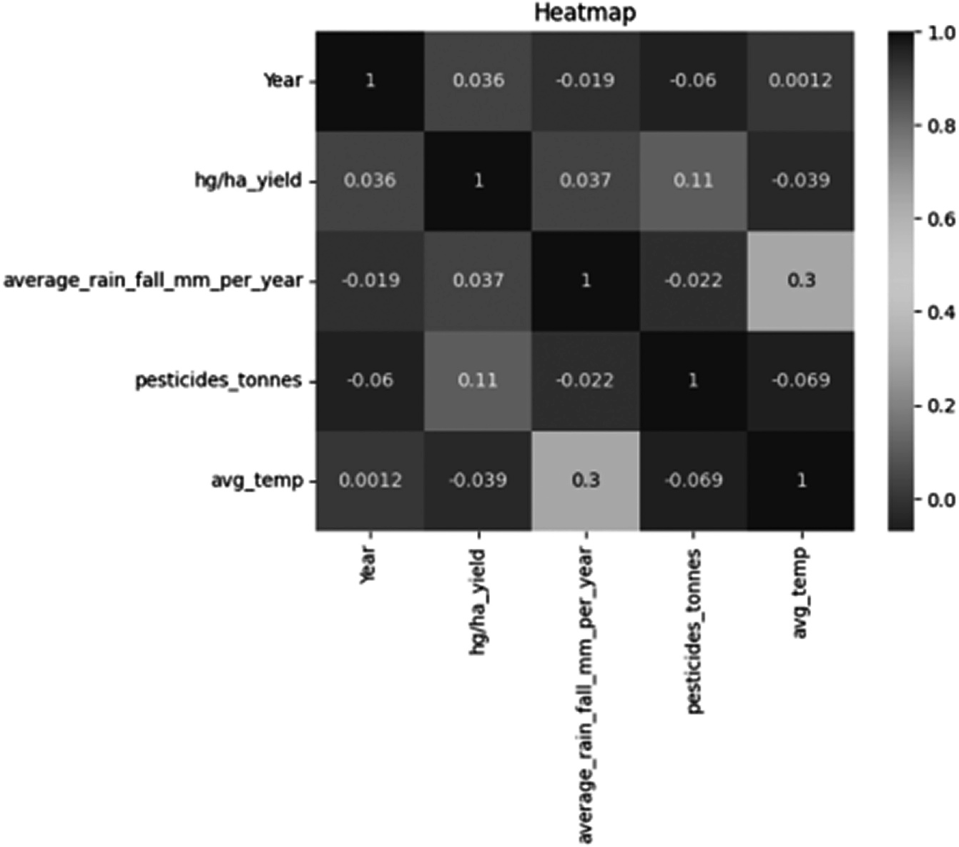
FIGURE 9.1
Heat map correlation for a given set of attributes.

As we can see here, we have taken five variables for analysis, as the oth- ers have been eliminated for not having enough relevance for the model to be used. Since the correlation ranges from −1 to 1 in a heat map (−1 indi- cating strong inverse correlation and 1 indicating strong correlation), ignoring the diagonal in the matrix, the highest change occurs in the crop yield depending on the variable pesticides_tonnes (0.11).

Linear Regression
Linear regression can be defined as a dependent variable’s link to one or more independent variables determined statistically. Based on the input value of another variable, it may be used to forecast the value of a vari- able. In the previously mentioned case, the variable whose value is found is known as the independent variable. The dependent variable is the one that is utilized to estimate the value of the independent variable.
Linear regression aims to find the best-fitting line that can encompass the values predicted and describe the link between the independent vari- able and dependent variables. It is commonly used to estimate trends in data. It is a productive statistical technique used in ML for predictive anal- ysis. The dependent variable and independent variable are shown to have a linear relationship. Typically, the values of the dependent variables are on the y-axis together with the values of the independent variables. The linear regression model is known as simple linear regression when there is just one input variable.
The best-fit line is calculated using the traditional slope-intercept for- mula, which is given as follows.

Y_{i} = α₀ + α₁X_{i}
(9.1)

In the Equation 9.1, Y_{i} denotes the dependant variable(s), which was pre- viously plotted on the y-axis, and X_{i} denotes the independent variable plotted on the x-axis. The coefficients α₀ and α₁ represent the constant/ intercept value and the slope of the best-fit line, respectively.

Polynomial Regression
In certain cases, the points plotted on an x–y regression graph may be nonlinear and, therefore, a single straight best-fit line might not include or account for all the points. To accommodate this scenario, we require the

implementation of polynomial regression models. That is, to overcome the conditions of underfitting or overfitting due to the usage of a straight line as the best-fit line, polynomial regression is used. Polynomial regression helps identify the curvilinear association between dependent and inde- pendent variables. In polynomial regression, the association between the dependent and independent variables is modeled as a pth degree polyno- mial function.
Only under these conditions can polynomial regression be performed. Additionally, it is expected that the mistakes are random, regularly dis- tributed with a mean of zero, and variance is constant. Some characteris- tics of polynomial regression are that the degree of the function can be altered to determine the best-fit line for a given set of points, and the model is prone to outliers, which can influence the result. The standard formula for polynomial regression can be given as in Equation 9.2.

g ( y ) = d₀ + d₁ y + d₂ y² +…+ d_{p} y ^{p}
(9.2)

Where p is the degree of the polynomial and d is the set of coefficients. For lower degrees, the relationship has specific names, depending on the value of when the value of p is 2, it is known as a quadratic regression model, and similarly, when the value of p is 3 and 4, it is known as cubic and quartic regression models, respectively. The method of least squares is typically used to fit polynomial regression models, minimizing the variance of the coefficients. Selecting the right degree (p) for a model is essential as it pre- vents overfitting or underfitting.

XGBoost
XGBoost stands for eXtreme Gradient Boosting. It is a product of gradient- boosted decision trees that can deliver results with high speeds and perfor- mance. It is useful in achieving results on many ML challenges. It largely works on gradient boosting, which is a supervised ensemble learning algo- rithm, wherein it attempts to predict values by combining the estimates of a set of simpler, weaker models.
It is highly preferred due to its ability to manipulate substantially large datasets and perform well in cases of tasks involving regression and clas- sification. Due to its ability to manage missing values without requiring preprocessing of the input, it is well-liked. Additionally, it includes

integrated parallel processing functionality, allowing it to train models quickly with big datasets.
Decision trees are built sequentially in the algorithm. Weight is an important parameter in XGBoost. Weights are associated individually with all the independent variables; these are then inputted into the deci- sion trees, which predict the result. Multiple decision trees are utilized to refine the predicted results by feeding data forwards; this is known as ensemble learning. The first-order derivative (gradient) and second-order derivative (Hessian) of the loss function are calculated for each data point, as depicted in Equations 9.3 and 9.4, respectively. These values are used to build the individual trees and adjust the model.
Regression Gradient (gᵢ) for MSE:

g_{i} = −2∗ ( y_{i} − y_{i} )
Regression Hessian (hᵢ) for MSE:

(9.3)

hi = 2 (9.4)
The recursive adjustment process adopted by the algorithm makes it efficient in capturing complex relationships with data, thus making it increasingly accurate at capturing nonlinear patterns and interactions. It uses a regularization value in its objective function. XGBoost includes L1 (Lasso) and L2 (Ridge) regularization terms to control the complexity of the individual trees and prevent overfitting.

Regularized Objective
= Objective + Penalty Regularized Objective
= Objective + Penalty

This is essential in preventing overfitting, which is a condition where the ML model becomes too tailored to the training data that it cannot adapt to a new dataset. In XGBoost, the regularization technique aids in ensuring a strong correlation between the result produced by the model with respect to the training dataset and the test dataset. The ensemble approach adopted also enables the algorithm to harness the strength of multiple models while also mitigating their weaknesses. XGBoost is highly preferred, as it is open-source software that undergoes continuous development by con- tributing professionals in the field.

KNN
The ML technique K-nearest neighbors, often known as KNN, is frequently employed for classification and regression issues. It is an instance-based algorithm that, unlike other algorithms, does not build an explicit algo- rithm during its training stage. It is an algorithm based on the supervised learning technique. The KNN algorithm memorizes the entire training dataset and, in response to an unknown data point, locates the K-nearest points in the training dataset and assigns the new value to the class or label based on a majority vote or an average of the k neighbors. This is done by using the Euclidean distance for continuous features and the Hamming distance for categorical features. Euclidean distance between two points p and q in a d-dimensional space is shown in Equation 9.5:

Euclidean Distance ( p,q) =
∑(Pi − qi )2
d
i =1
(9.5)

The algorithm has two parameters – namely, K and distance metric. K is the number of neighbors to consider. It is a crucial hyperparameter in the algorithm, and the accurate selection of the same can significantly impact the performance of the algorithm. Distance metrics are used to find the alikeness between two given data points. While KNN is a simple algo- rithm, it has some limitations, such as sensitivity to the value of k, sensitiv- ity to the choice of distance metric, and computational inefficiency with large datasets.

RESULTS AND DISCUSSION
This section’s primary goal is to present the results of the model experi- ments. After the various prediction models have been trained, we may use Python 3.8.0 to run simulations. Consistent findings will be produced as the number of tests is increased. As a result, we will assess how effective the ML models outlined are in predicting crop yield overall in this section.

Model Evaluation
      - Mean Squared Error
The MSE emerges as a crucial parameter illuminating the predic- tive efficacy of the ML models employed in this crop production

prediction study. It calculates the squared difference between the anticipated crop yield and the observed yield for each data point in the dataset. The computation of the MSE involves summing up all these squared differences and subsequently taking an average across all the data points. Mathematically, this process can be expressed as in Equation 9.6:
MSE = 1/ n ∗£ (actual yield − predicted yield)2
(9.6)
In this context, the variable “n” represents the total count of data points. A lower MSE value indicates that the models – namely, XGBoost, polynomial regression, and KNN – produce predictions that closely correspond to the observed crop yields. A reduced MSE suggests that the models successfully capture the intrinsic patterns and fluctuations within the data, thereby enhancing the overall reli- ability of their predictions.
As we can see in Figure 9.2, the x-axis represents the name of the model that we’ve used, and the y-axis represents the respective MSE. The values range from 0.0 to 3.0, as seen on the y-axis. Here, the lower the bar for each model, the better its performance, as the error is lower.

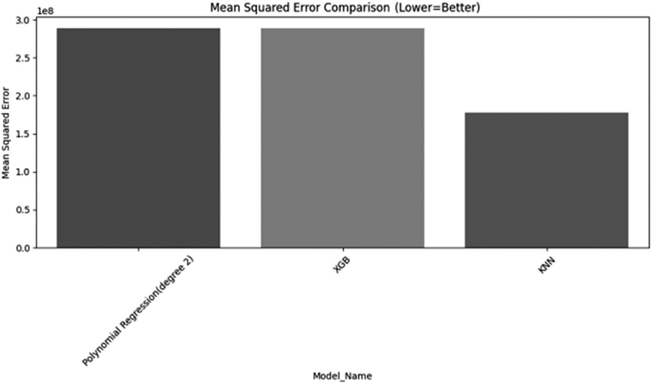
FIGURE 9.2
Mean square error comparisons.

R-squared (R2) Score
During the evaluation of how effectively the ML models align with the observed crop yield data, the R-squared (R2) score assumes a piv- otal role. This metric quantifies the proportion of total variance in the crop yield data that the models are capable of accounting for. Utilizing the R2 score allows for an assessment of the performance of the XGBoost, polynomial regression, and KNN models in relation to a reference model.
A value of 0 for R2 (which ranges between 0 and 1) indicates that, much like a basic average model, the models cannot account for any variations in crop yields. Conversely, an R2 score of 1 signifies that the models are adept at capturing all the variability present in the data, resulting in predictions that precisely match the observed yields.
In this study, higher R2 scores demonstrate the models’ proficiency in discerning crucial patterns and trends within the crop yield data. These outcomes underscore the importance and reliability of the models’ predictions, as they indicate that a substantial portion of the yield variability is accurately captured by the models.
As we can see in Figure 9.3, the x-axis represents the name of the model that we’ve used, and the y-axis represents the respective R-squared score. The values range from 0.0 to 0.8, as seen on the y-axis. Here, the higher the bar for each model, the better its performance, as the score is higher.
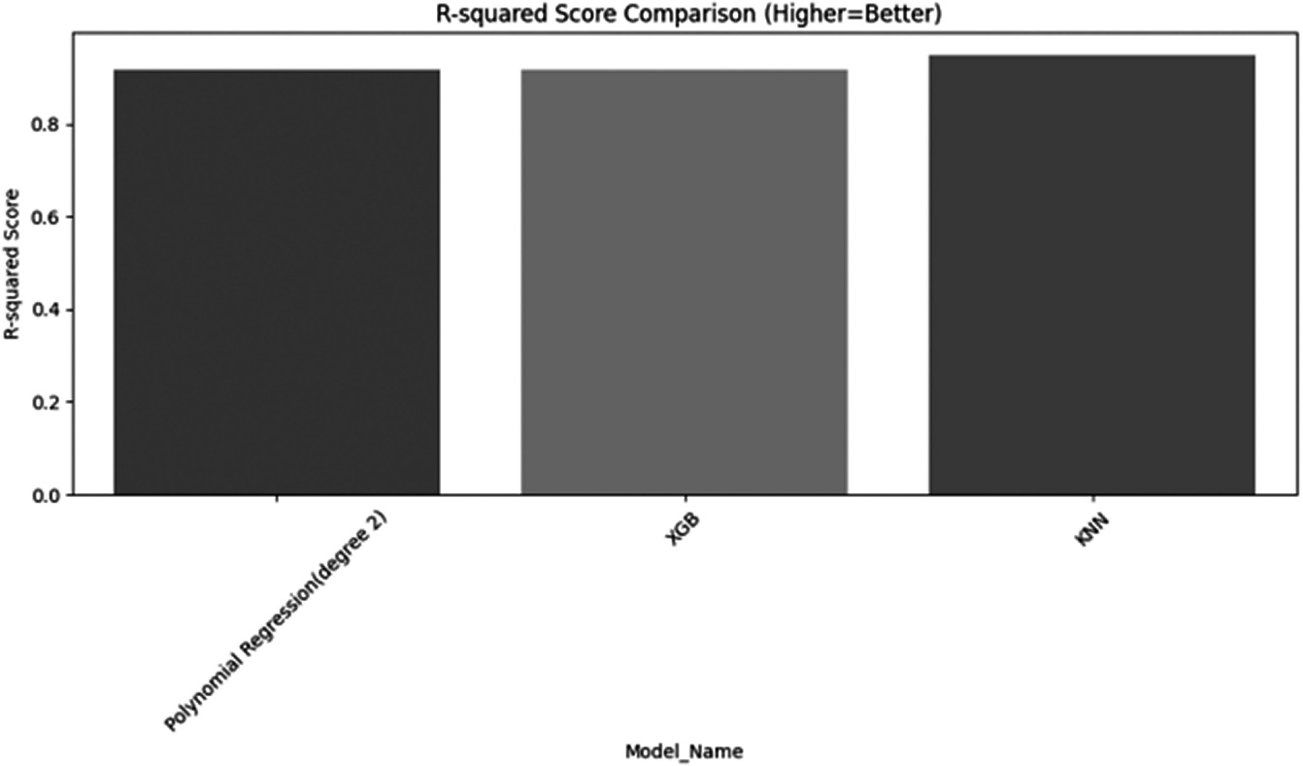
FIGURE 9.3
R-square error comparisons.

CONCLUSION
ML has become an essential decision-support tool for forecasting crop yields in agriculture, enabling well-informed decisions on crop selection and management all through the growing season. In order to estimate crop yields, this study used a comparative analysis with three ML mod- els: linear regression, polynomial regression, and KNN. To improve the agricultural sector, it is essential to anticipate crop yields based on these variables, which include temperature, pesticide use, rainfall, and climatic conditions. The obtained dataset underwent extensive preprocessing to remove redundant or incorrect data prior to model training. After that, the dataset was split into training and testing subsets so that the perfor- mance metrics of each model could be assessed. Running the three ML models we had taken, we got to see that KNN had both the least MSE: 1.776102e + 08 and the highest R2 score: 0.948888. Although it performed well in these metrics, KNN should be used carefully, as it can tend to over- fit the data, and if not, XGBoost will provide a similar result in most cases. These models can be used to improve the efficiency of farming by helping provide efficient use of materials and resources. This study highlights how ML can improve agricultural productivity and decision-making, thereby assisting in the farming industry’s sustainable growth. In order to opti- mize crop output and adapt to shifting environmental conditions, farmers and policymakers can use ML to their advantage. This will ensure food security and economic growth in the agricultural sector.

REFERENCES
- “Economic Survey 2022–23: Agri growth rate falls but sector still resilient amid pandemic shock,” www.downtoearth.org.in. https://www.downtoearth.org.in/news/ agriculture/economic-survey-2022-23-agri-growth-rate-falls-but-sector-still- resilient-amid-pandemic-shock-87406
- N. Alex, C. C. Sobin, and J. Ali, “A comprehensive study on smart agriculture appli- cations in India,” Wireless Personal Communications, vol. 129, no. 4, pp. 2345–2385, Mar. 2023. doi: 10.1007/s11277-023-10234-5
- K. P. Kumar, A. Unal, V. J. Pillai, H. Murthy, and M. Niranjanamurthy, eds., Data Engineering and Data Science: Concepts and Applications. 2023. ISBN: 9781119841876.
- A. Nigam, S. Garg, A. Agrawal, and P. Agrawal, “Crop yield prediction using machine learning algorithms,” 2019 Fifth International Conference on Image Information Processing (ICIIP), Shimla, India, 2019, pp. 125–130. doi: 10.1109/ ICIIP47207.2019.8985951

- K. P. Kumar, H. Murthy, V. J. Pillai, and B. R. Prathap, “Blockchain-enabled model for minimizing post harvest losses,” ECS Transactions, vol. 107, no. 1, p. 17475, 2022. doi: 10.1149/10701.17475ecst
- I. A. Supro, “Rice yield prediction and optimization using association rules and neural network methods to enhance agribusiness,” Indian Journal of Science and Technology, vol. 13, no. 13, pp. 1367–1379, Apr. 2020. doi: 10.17485/ijst/v13i13.79
- P. S. S. Gopi and M. Karthikeyan, “Red fox optimization with ensemble recurrent neural network for crop recommendation and yield prediction model,” Multimedia Tools and Applications, vol. 83, pp. 1–21, Jul. 2023.
- S. Muthukumaran, P. Geetha, and E. Ramaraj, “Multi-objective optimization with artificial neural network based robust paddy yield prediction model,” Intelligent Automation & Soft Computing, vol. 35, no. 1, pp. 215–230, 2023. doi: 10.32604/ iasc.2023.027449
- K. Vignesh, A. Askarunisa, and A. M. Abirami, “Optimized deep learning methods for crop yield prediction,” Computer Systems Science and Engineering, vol. 44, no. 2,
pp. 1051–1067, 2023. doi: 10.32604/csse.2023.024475
- M. Yoosefzadeh-Najafabadi, D. Tulpan, and M. Eskandari, “Application of machine learning and genetic optimization algorithms for modeling and optimizing soybean yield using its component traits,” PLOS ONE, vol. 16, no. 4, p. e0250665, Apr. 2021. doi: 10.1371/journal.pone.0250665
- G. Sunitha et al., “Modeling of chaotic political optimizer for crop yield predic- tion,” Intelligent Automation & Soft Computing, vol. 34, no. 1, pp. 423–437, 2022. doi: 10.32604/iasc.2022.024757
- H. Dokoohaki, T. Rai, M. Kivi, P. Lewis, J. Gómez-Dans, and F. Yin, “Linking remote sensing with APSIM through emulation and Bayesian optimization to improve yield prediction,” Remote Sensing, vol. 14, no. 21, pp. 5389, Oct. 2022. doi: 10.3390/ rs14215389
- C. Chen, X. Wang, H. Chen, C. Wu, M. Mafarja, and H. Turabieh, “Towards pre- cision fertilization: Multi-strategy grey wolf optimizer based model evaluation and yield estimation,” Electronics, vol. 10, no. 18, p. 2183, Sep. 2021. doi: 10.3390/ electronics10182183
- U. Bhimavarapu, G. Battineni, and N. Chintalapudi, “Improved optimization algo- rithm in LSTM to predict crop yield,” Computers, vol. 12, no. 1, p. 10, Jan. 2023. doi: 10.3390/computers12010010
- K. P. Kumar, H. Murthy, V. J. Pillai, B. R. Prathap, M. Moses, and Y. Urs, “Data analysis and machine learning observation on production losses in the food pro- cessing industry,” 2023 IEEE International Conference on Contemporary Computing and Communications (InC4), Bangalore, India, 2023, pp. 1–4. doi: 10.1109/ InC457730.2023.10263147
- R. Barzin, R. Pathak, H. Lotfi, J. J. Varco, and G. C. Bora, “Use of UAS multispectral imagery at different physiological stages for yield prediction and input resource opti- mization in corn,” Remote Sensing, vol. 12, no. 15, pp. 2392, Jul. 2020. doi: 10.3390/ rs12152392

- P. S. Maya Gopal and R. Bhargavi, “Selection of important features for optimizing crop yield prediction,” International Journal of Agricultural and Environmental Information Systems, vol. 10, no. 3, pp. 54–71, Jul. 2019. doi: 10.4018/ijaeis.2019070104
- P. C. Roy, A. Guber, M. Abouali, A. P. Nejadhashemi, K. Deb, and A. J. M. Smucker, “Crop yield simulation optimization using precision irrigation and subsurface water retention technology,” Environmental Modelling & Software, vol. 119, pp. 433–444, Sep. 2019. doi: 10.1016/j.envsoft.2019.07.006

